**Name: Rithiha S.P**

**Regno: URK20CS2076**

**Exp 7 – Web Technology Lab**

**Link of Website:**

**Link of Video:**

**Aim:**

To use jQuery to implement the following questions containing Dynamic forms as well as changing CSS properties.

**Questions:**

1. Car moving animation using jquery

<!DOCTYPE html>

<html lang="en">

<head>

<meta charset="UTF-8">

<meta http-equiv="X-UA-Compatible" content="IE=edge">

<meta name="viewport" content="width=device-width, initial-scale=1.0">

<title>Document</title>

<script src="https://ajax.googleapis.com/ajax/libs/jquery/3.6.0/jquery.min.js"> </script>

<script>

$(document).ready(function() {

$(document).keydown (function(event) {

event.preventDefault();

let key = event.which; // 37-left, 38-up, 39-right, 40-down

let car = $('#car');

switch (key) {

case 37:

{car.css('transform', 'rotateY(180deg)')

car.animate({left: "-=5px"}, 1);

break;}

case 38:

{car.css('transform', 'rotate(270deg)')

car.animate({top: "-=5px"}, 1);

break;}

case 39:

{car.css('transform', 'rotate(0deg)')

car.animate({left: "+=5px"}, 1);

break;}

case 40:

{car.css('transform', 'rotate(90deg)')

car.animate({top: "+=5px"}, 1);

break;}

}

})

})

</script>

</head>

<body>

<div id="car" style="position: absolute; left:5px; top: 10px; width: 130px; height: 140px;">

<img src="car.png" alt="moving car" height="140px" width="230px">

</div>

</body>

</html>

**OUTPUT:**

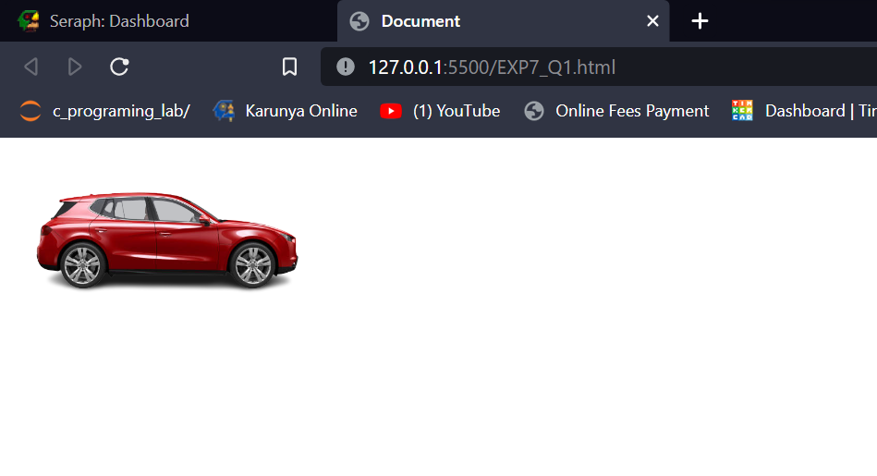

1. Create a dynamic Registration form and display it in the same page using JQuery
2. Use Dom_get and dom_set to the set the values to the form
3. Dynamically add buttons and remove buttons
4. Use traversing function to display dynamically generated value in the result display portion

<!DOCTYPE html>

<html lang="en">

<head>

<meta charset="UTF-8">

<meta http-equiv="X-UA-Compatible" content="IE=edge">

<meta name="viewport" content="width=device-width, initial-scale=1.0">

<title>Document</title>

<script src="https://ajax.googleapis.com/ajax/libs/jquery/3.6.0/jquery.min.js"> </script>

<script>

$(document).ready(function() {

$('#btn1').click(function() {

$('.container').append("<div> Enter data : <input type='text'> <br><br> </div>");

})

$('#btn2').click(function() {

$('.container').children().last().remove();

})

})

</script>

</head>

<body>

<button id="btn1"> Add TextBox </button>

<button id="btn2"> Remove TextBox </button>

<br><br>

<div class="container"> </div>

</body>

</html>



1. Create a car body workshop using JQuery wherein you should be able to change the car's color, glass tint, and size of the tires.

<!DOCTYPE html>

<html>

<head>

<meta name="viewport" content="width=device-width, initial-scale=1">

<style>

.trapezoid {

border-bottom: 50px solid #555;

border-left: 25px solid transparent;

border-right: 25px solid transparent;

height: 0px;

width: 125px;

padding-left: 10px;

}

.tyre {

height: 50px;

width: 50px;

background-color: #555;

border-radius: 50%;

margin-left: 20px;

}

.rectangle {

height: 50px;

width: 250px;

background-color: #555;

}

#tyre2 {

margin-left: 180px;

margin-top: -50px;

}

</style>

<script src="https://ajax.googleapis.com/ajax/libs/jquery/3.6.0/jquery.min.js"> </script>

<script>

$(document).ready( function() {

$('#tyre').click( function() {

var newColor = prompt('Enter new tyre color', '#555');

$('.tyre').css('background-color', newColor);

})

$('#body').click( function() {

var newColor = prompt('Enter new car body color', '#555');

$('.rectangle').css('background-color', newColor);

})

$('#window').click( function() {

var newColor = prompt('Enter new window color', '#555');

var final = '50px solid ' + newColor;

$('.trapezoid').css('border-bottom', final);

$('.trapezoid').css('bordder-left', '25px solid transparent');

$('.trapezoid').css('border-right', '25px solid transparent');

$('.trapezoid').css('height', '0px');

$('.trapezoid').css('width', '125px');

})

$('#tyre-size').click( function() {

var newHeight = prompt('Enter new tyre height', '50px');

var newWidth = prompt('Enter new tyre width', '50px');

var tp_margin = "-"+newHeight;

$('#tyre2').css('margin-top', tp_margin);

$('.tyre').css('border-radius', '50%');

$('.tyre').css('height', newHeight);

$('.tyre').css('width', newWidth);

})

})

</script>

</head>

<body>

<h2>Trapezoid CSS</h2>

&nbsp;&nbsp;

<div class="trapezoid "></div>

<div class="rectangle "></div>

<div class="tyre " id="tyre1"></div>

<div class="tyre " id="tyre2"></div>

<br>

<button id="tyre" > Change tyre color </button>

<button id="body"> Change body color </button>

<button id="tyre-size"> Change tyre size </button>

<button id="window"> Change window tinting </button>

<div id="something"></div>

</body>

</html>

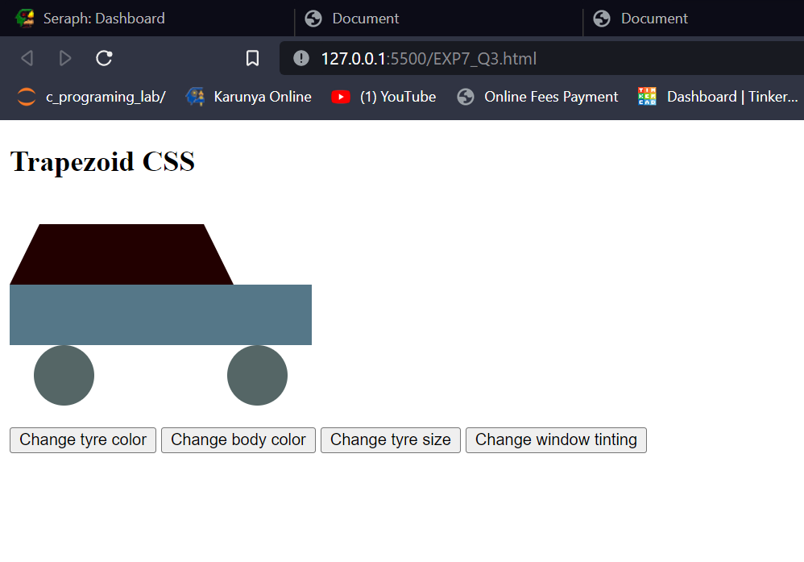

**Result:**

Thus, the experiment for jQuery has been coded, executed, and verified successfully.